Honorary Master Pork Producers
(Listed job titles and affiliations are from time of award.)

2023
Kaisand, Dr. Jeff - State Veterinarian
Rothschild, Dr. Max - Iowa State University
Stalder, Dr. Ken - Iowa State University

2022
Dierks, Neil - Retired CEO, National Pork Producers Council
Hayes, Dr. Dermot J. - Iowa State University, Professor of Economics, Charles F. Curtiss Distinguished Professor in Agriculture and Life Sciences

2021
Fitzgerald, Jerry - Lobbyist, Fitzgerald, Smith & Associates
Reynolds, Kim - Iowa Governor

2020
Miller, Tom - Iowa State University Extension and Outreach, Field Swine Specialist (retired)

2019
Beermann, Dr. Donald - Iowa State University, Chair – Dept. of Animal Science
Pride, Jason - Hy-Vee, Vice President of Meat & Seafood

2018
Lynch, Gary – CEO, Lynch Family Companies, Waucoma
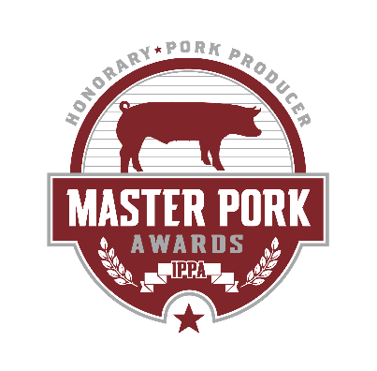
Schmitt, Dr. David – State Veterinarian of Iowa

2017
Ernst, Joni - U.S. Senator from Iowa
Patience, Dr. John - Iowa State University, Professor of Animal Science

2016
Degner, Rich - Retired CEO, Iowa Pork Producers Association

2015
Durham, Debi – Director, Iowa Economic Development Authority
Hoff, Dr. Steven - Iowa State University, Professor, Agricultural and Biosystems Engineering

2014
Baker, Dr. Butch - Iowa State University College of Veterinary Medicine, Senior Clinician

2013
Main, Dr. Rodger - Director of Operations, Iowa State University Veterinary Diagnostic Laboratory
Mertz, Dolores - Retired Iowa State Representative from Ottosen

2012
Barnes, Ernie - National Pork Board Director of Producer and Industry Services
Miller, Marlys – Editor, Pork Magazine

2011
Northey, Bill - Iowa Secretary of Agriculture
Quinn, Bob - WHO Radio

2010
Baas, Dr. Tom - Iowa State University, Professor of Animal Science
Meyer, Dr. Steve - President, Paragon Economics Inc.

2009
McAfee, Eldon - Attorney, Beving, Swanson & Forrest, P.C.
Putze, Aaron - Executive Director & Public Relations Officer, Coalition to Support Iowa’s Farmers

2008
Wintersteen, Dr. Wendy - Iowa State University, Dean of College of Agriculture and Life Sciences,
Fischer, Mark - International Marketing Manager for Meat, Livestock, and Genetics, Iowa Department of Economic Development

2007
Greiner, Sandy - Iowa State Representative
Hogberg, Dr. Maynard - Iowa State University, Chair of Department of Animal Science

2006
Thomson, Dr. John - Iowa State University, Dean of College of Veterinary Medicine
Mabry, Dr. John - Iowa State University, Director of Iowa Pork Industry Center

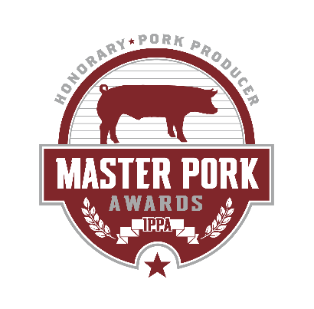
2005
Hommes, Harold - Iowa Department of Agriculture & Land Stewardship,
Marketing Bureau Chief
Machan, Gary - Tyson Fresh Meats Inc., Senior Vice President

2004
Miller, Dale - Editor, National Hog Farmer
Halbur, Dr. Pat - Iowa State University, Chair of Veterinary Diagnostic Laboratory

2003
Parrish, Dr. F. C. - Iowa State University, Professor of Meat Science
Pearson, Mark - WHO Radio Farm Broadcaster & Market-to-Market Host

2002
Judge, Patty - Iowa Secretary of Agriculture
Nichol, Bud - Former Owner of Iowa Quality Meats

2001
Clement, Larry – Owner, Tri State Motor Sports
Whalen, Mike – CEO, Heart of America Restaurants

2000
Grassley, Charles E. - U.S. Senator from Iowa
Telford, Michael L. - Iowa State University Foundation; former CEO of Iowa Pork Producers Association

1999
Braynard, Dale - Iowa Department of Economic Development, Manager of Meat Promotion
Marple, Dr. Dennis - Iowa State University, Chair, Department of Animal Science

1998
Wergin, Gary - WHO Radio
Lawrence, Dr. John - Iowa State University Extension Livestock Economist

1997
Cheever, Ray - IBP
May, Jack – President, Kent Feeds
Balvanz, Rich - WMT Radio

1996
Topel, Dr. David - Iowa State University, Dean of the College of Agriculture
Christian, Allen - Iowa State University, Swine Teaching Farm Manager
Gingerich, Don – Past President of NPPC and IPPA, Parnell

1995
Jischke, Dr. Martin – President, Iowa State University
Smith, Tim - Hills Bank & Trust, Senior Vice President

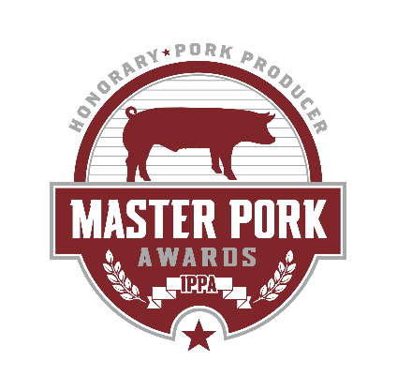
1994
Alyea-Smith, Char - Results Inc.
Hill, Dr. Howard - Iowa State University, Veterinary Diagnostic Lab, Director of Veterinary Microbiology Section
Petersen, Kenny - Pete’s Supper Club, Hartley

1993
Branstad, Terry - Iowa Governor
Henderson, Douglas - Iowa State University Extension
Smith, Neal - U.S. Representative from Iowa

1992
Thoma, Mike - The Machine Shed Restaurant
Struve, Dr. Rexanne - Veterinary Associates

1991
Alumbaugh, JoAnn - Farm Progress Publications
Hamilton, Neil - Drake University Law Department

1990
Ewing, Dr. Solon “Bud” - Iowa State University
Fleming, Bill - National Hog Farmer
Juhl, Dick – Mechanicsville

1989
Frier, Jim - Washington
McGinnis, Dallas - Ames
Warwick, Jerry - Elanco

1988
Armbrecht, Dr. Paul - Lake City
Curran, Dr. Bernie - Eldridge
Hanna, Hal - KXEL Radio

1987
Germann, Larry - Morrell & Co.
Fleenor, Jim - Ida Grove

1986
Swensen, Jerry - Oscar Mayer
Schultz, Dr. Roy - Veterinarian
Holden, Dr. Palmer - Iowa State University

1985
Cooper, Doug - KWMT Radio
McKean, Dr. Jim - Iowa State University
Wahlert, Robert H. - FDL Foods Inc.

1984
Lightfoot, Jim Ross - Farm Broadcaster & U.S. Representative from Iowa
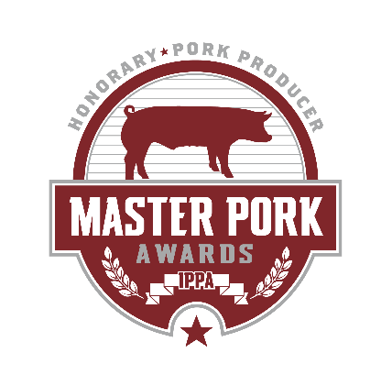
Rich, Don - Yoder Feed
Ross, Dr. Richard - Iowa State University

1983
Sylvester, Dave - KOEL Radio
Trewin, Bob - Northeast lowa Test Station

1982
DeGroot, John - Rath Packing Company
Hasler, Dick - Wilson Foods
Pryor, Doug - Cedar Falls

1981
Lang, Dr. Merle - State Veterinarian of Iowa
Passer, Jerry - WMT Radio

1980
Christian, Dr. Lauren - Iowa State University
Mobley, Earl - Extension Livestock
Wendt, Kenneth - Ames Test Station

1979
Faint, LeRoy - Farmland Industries
Garner, J. Marvin - formerly with National Pork Producers Council
Kolmer, Lee - Iowa State University

1978
Doran, Gene - Ames Boar Test Station
Ray, Robert D. - Iowa Governor

1977
Kunesh, Jerry - Iowa State University

1976
Forrest, F. H. “Mike” - Lobbyist

1975
Heffernan, Keith - Des Moines
Kingston, Clayton - Hormel & Company

1974
Elam, Paul - FS Services
Stevermer, Emmett - Iowa State University

1973
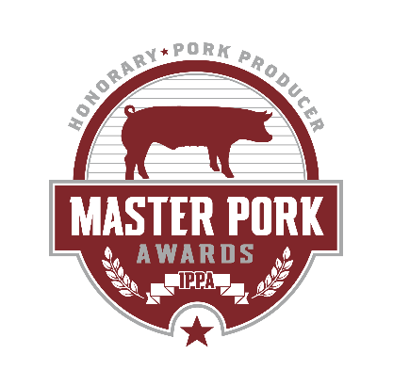
Anderson, J. Merrill - Pres., Iowa Farm Bureau Federation
Olson, Leon - Pride of The Farm

1972
Ford, Mike - Wallaces Farmer
Foudree, Shie - Des Moines
Van Gilst, Bass - State Senator
Nuss, James - CED

1971
Flint, Dave - Vocational Agriculture Department
Fulk, Kenneth - Secretary, Iowa State Fair
Goodwin, Norman - CED

1970
Butler, Dr. Elliot - Des Moines
Huinker, Dave - Ames
Mindermann, Harold – Iowa Farm Bureau Federation Commodities Director

1969
Casey, Robert - Ida Grove
Donels, Ray - Iowa State University
Murphy, Dan - Des Moines
Stephens, Richard - Ainsworth

1968
Andre, Dean Floyd - Iowa State University
Gadd, Robert - Fort Dodge
Kirkpatrick, Keith - WHO Radio

1967
Walk, Chuck - Mason City Globe Gazette
Wedman, Dr. Ed - Veterinary Med. Res. Inst.
Whitaker, Dr. Mack - Iowa State University

1966
Baker, Don - Iowa State University
Knau, Craighton - WNAX Radio
Paul, Rolland - National Pork Producers Council
1965
Bretey, Jerry - KWMT Radio
Crabb, Frank - Farmbest
Hays, Virgil - Iowa State University
Speer, Vaughn - Iowa State University

1964
Duman, Leonard - Oscar Mayer
Nance, Bob - WMT Radio
Switzer, Dr. William - Iowa State University

1963
Muhm, Don - Des Moines Register
Pomeroy, Dr. M. E. - State Veterinarian
Rust, Robert - Iowa State University

1962
Kline, Lee - WHO Radio
Morrissey, Thomas J. - Hog Breeding Farm
Zmolek, William - Iowa State University

1961
Albrecht, Dick - Wallaces Farmer
Kline, Dr. Ed - Iowa State University
Steddom, Marion - Pork Producer

1960
Brown, Verald - Purebred Breeder
Mitchell, C. R. - National Hog Farmer
Williams, Dale - Iowa State University

1959
Johnson, Dr. Leslie - Animal Husbandry Dept.
Rinner, Dean - Wilson & Company
Spry, Clyde - Iowa Secretary of Agriculture

1958
Conn, Rex - Farm Editor
Durham, Dr. Ralph - Ext. Animal Husbandman
Hamilton, V. B. - Farmers Hybrid Hogs

1957
Meneough, Henry - Premier Swine Breeder
Plager, Russell - Morrell & Company
Spear, Dr. Maynard - Extension Veterinarian

1956
Diggins, R. V. - Voc. Ag. Instructor
Lush, Dr. Jay L. - Iowa State College
Wolrab, Milo - Premier Swine Breeder

1955
Ebbing, Bernard - Rath Packing Company
Garrett, Dr. H. U. - State Veterinarian
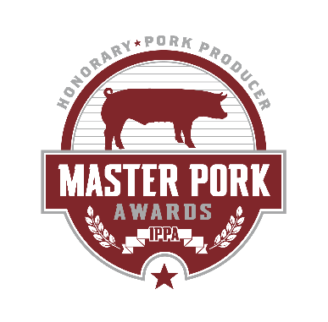
Kutish, Francis - Iowa State College

1954
Culbertson, C. C. - Iowa State College
Knotek, John - Purebred Breeder

1953
Groves, Bill - Pork Producer
Hazel, Dr. L. N. - Iowa State College
Plager, Carroll - Hormel & Company

1952
Wallace, James - Iowa State College
Urban, Karl - Mkt. News Soc.

1951
Catron, Damon - Iowa State College
Pemberton, R. L. - Hampshire Record Assn.
Plambeck, Herb - WHO Radio

1950
Coverdale, John - Rath Packing Company
Plager, Wilbur - Iowa Swine Producers
Shearer, P. S. - Iowa State College

1949
Cunningham, Glenn - Register & Tribune
Fisher, Harry - Farmer
Nash, Allen - Wilson & Company

1948
Anderson, A. L. - Iowa State College
Diamond, William T. - American Feed Mfgs.
Elijah, Earl - Farmer

1947
Craft, Dr. W. A. - Iowa State College
Hush, Homer - Wallaces Farmer
Sutton, Lyle - Farmer

1946
Kildee, Dean H. H. - Iowa State College
Quaife, E. L. - Iowa State College
Yungclas, William - Iowa Swine Producers

1945
Blise, R. K. - Iowa State College
Hill, Howard - Iowa Farm Bureau
Hoffman, George – Farmer
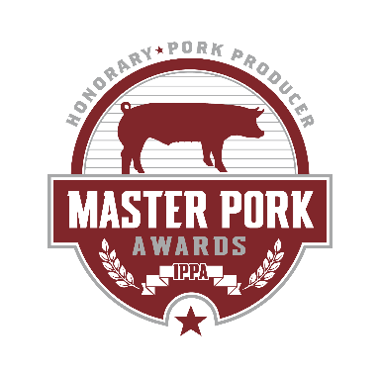
1944
Kline, Allan - American Farm Bureau
Plambeck, H. T. - Retired Farmer

